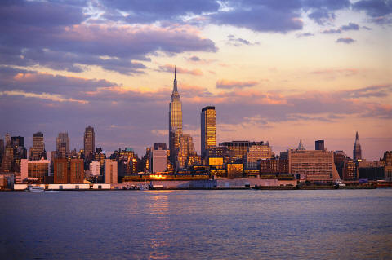
New York,
NewYork

~at Christmastime~

*****************************

Presented by WENDT TOURING

Take a bite of the Big Apple! New York City has an endless variety of fine cuisine, one of a kind shops and stunning architecture. Visit this dynamic international city known for great theatre, historic landmarks and world-class museums. This time we go during the magical Christmas holiday season and stay at a first class hotel located directly in Manhattan and in the heart of NYC. Enjoy all the must see sights and sounds that New York City has to offer and get into the Christmas spirit on this unforgettable vacation.

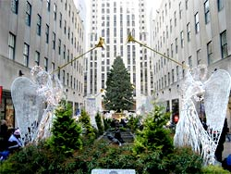
HIGHLIGHTS INCLUDE
Broadway Theatre ~ Rockefeller Plaza ~ Fifth Avenue ~ Chinatown
Little Italy ~ Greenwich Village ~ Battery Park ~ Ground Zero
St. Patrick’s Cathedral ~ Central Park ~ Times Square ~ Wall Street
United Nations Headquarters ~ Chrysler Building ~ Empire State Building
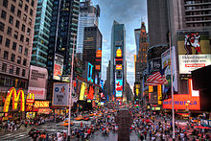
TOUR INCLUDES:
*Deluxe motorcoach transportation
*Three nights lodging in New York City
*Four meals – 2B & 2D
*All sightseeing & entrance fees
*Baggage handling & gratuities
*Broadway Theatre Show

TOUR FARE:
Please call for current tour pricing

Travel arrangements made by Wendt Touring, Inc.
401 Market Street – Suite 707, Steubenville, OH 43952
740-282-5790 or toll-free 1-877-565-8687
www.WendtTouring.com

ITINERARY

Day 1 – Home City – New York City, New York: Travel aboard a deluxe highway coach en route to New York City. Rest and meal stops will be made periodically. There is nothing like Christmastime in NYC – the colorful lights, outstanding special events and dazzling holiday decorations abound. Our hotel for all four days is in midtown Manhattan – located in the heart of the “Big Apple.” This evening we gather for dinner at a local restaurant.

Day 2 – New York City Sightseeing – St. Patrick Cathedral – Rockefeller Plaza – Times Square – Broadway Musical: Today following breakfast we embark on a delightful tour of Midtown Manhattan with a local guide. Travel along beautiful Central Park. See the United Nations Headquarters, Trump Towers, Park Avenue, St. Patrick’s Cathedral, Grand Central Station, the iconic Chrysler Building and Madison Avenue. Enjoy free time for lunch and shopping on Fifth Avenue and browsing at Rockefeller Plaza which houses 24 acres of upscale underground shops and restaurants. Other sightseeing highlights include Lincoln Center for the Performing Arts, Radio City Music Hall, the Empire State Building and the electrifying Times Square. This evening a special dinner is included followed by reserved theater seating at a Broadway musical show.

Day 3 – New York City Sightseeing – Lower Manhattan – 911 Memorial: Breakfast included. This morning our sightseeing concentrates on Lower Manhattan: colorful Greenwich Village, Little Italy, Chinatown, Soho and Battery Park. See Wall Street, home of the New York Stock Exchange and the Federal Reserve Bank. Visit 911 Memorial of the World Trade Center Twin Towers Site and see the progress of the New Freedom Tower. This afternoon and evening are free to explore Gotham City as you wish: Ellis Island and the Statue of Liberty Monument, NBC Studios, famed New York Public Library, the Brooklyn Bridge or the Metropolitan Museum of Art. You may want to see another terrific Broadway Show or just do some unique Christmas shopping. The possibilities are endless.

Day 4 – New York City – Home City: Later this morning we leave New York City and begin our journey home. Rest and meal stops will be made periodically. Early evening arrival back home.

